Net Zero Hero status
We don’t inherit the Earth from our ancestors we borrow it from our children.
When we visit the natural world we are encouraged to leave with nothing but footprints.
In our personal lives, our work, our communities and our clubs, it is critical we do our utmost to keep our carbon footprints as low as possible and offset our residual C02e emissions, essentially, no footprint atall!
The Be a Hero Go Net Zero initiative provides a simple methodology to be as sure as we can, that as an individual having done everything within reason to minimise our footprint we offset the residual and self-declare as Net Zero.
There are numerous carbon calculators available. These are imprecise tools, but it is a classic case of not letting the perfect be the enemy of the good.
For club environmental footprints see ESRAG’s https://esrag.org/every-club-climate-friendly/ initiative.

Process
In order to self-declare Net 0 we suggest you run through two or three calculators, a range is suggested in Appendix I. Typically these take about five minutes each. Take the average and then offset that amount. This does not need to be expensive. Several Rotarians running environmental themed projects have calculated the donation that will offset a tonne of C02e. A range of organisations and projects that you may wish to use to offset your footprint are given in Appendix II.
We suggest you allow a 30% margin of error in the residual footprint and over compensate, but as a self-declaration it is down to whatever you are comfortable with. If you use Treekly, offsetting can be achieved without cost.
Once you are happy you are Net 0 just email either Mohammed or me and self-declare as Net 0. We will assign you a Net Zero Hero number and send you a certificate of achievement for one year from submission. We suggest you use your Net Zero Hero number in your email signature..
Be a Hero, Go Net Zero!
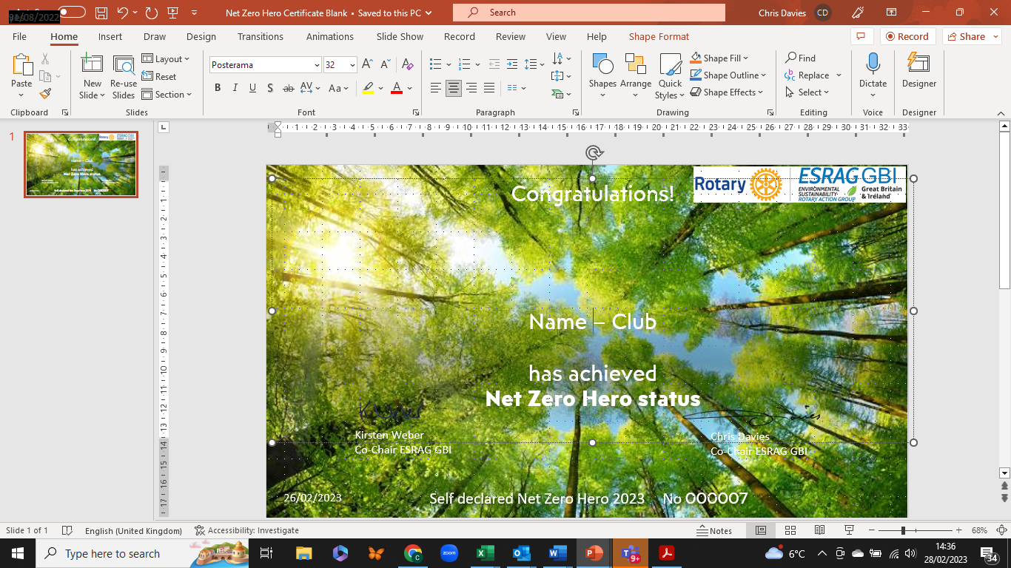

Appendix I
Carbon CALCULATORS:

Largely self-explanatory. Calculates a household footprint.
United Nations online platform for voluntary cancellation of certified emission reductions (CERs) (climateneutralnow.org)

Comprehensive, based on annual metrics and expenditure
https://www.carbonfootprint.com/calculator.aspx

Ecotricty
https://www.ecotricity.co.uk/carbon-footprint-calculator

Swiss based – a little vague at times – more subjective
https://co2.myclimate.org/en/footprint_calculators/new

World Wildlife Fund - Total Lifestyle Carbon calculator
https://footprint.wwf.org.uk/#/

ESRAG Flight offset Calculator
https://www.esrag.org/flight-carbon-offset-calculator

Appendix II –
A range of alternatives for offsetting your Carbon footprint. These are either Rotary or Rotary supported initiatives.
Stoves for schools: RTN Maya Smeulders <mayasmeulders@hotmail.com> where labour, transport and chimney costs need to be paid. In the case of the school stove, £250 saves 10.2 tonnes CO2 per year, so £25 will save 1 tonne CO2 per year.
£250 covers the costs of the tree nurseries we have set up and the distribution of the seedlings to schools and farms.
Solar Aid: RTN Rob Leaper- Danetre – Daventry. We are working with a UK charity – SolarAid – on a new project to replace kerosene lamps and candles, which generate CO2, with solar-powered home lighting systems.
The lighting system, called Sun King Home 60, can be installed in one dwelling for £100. It uses a solar panel and battery to provide power to 3 LED lights, enabling users to study in the evenings, work, provide medical aid, power mobiles and more.
The saving in CO2 and black carbon equivalent of one system is around 1.8 tonnes per year. Each system is guaranteed for 5 years, equating to a saving of 9 tonnes CO2 equivalent over the lifetime of the system.
Solar Account Name Rotary Club of Danetre Daventry, Sort Code 30-99-50, Account No. 31931460, Account Type Business. Please use as a reference; SoL Africa. Your contribution will be directed to a specific Carbon Offsetting solar project in Malawi - of which you will be kept fully informed.
Sustainable Global Gardens: – RTN Paul Keeley Paul Keeley <paul_keeley@hotmail.com>runs: SGG has a stock of trees that are 5+ years old planted in 2017-2018. We pay farmers £10 per year to maintain 50 trees which will offset I tonne of CO2 equivalent per year. We use mature trees rather than newly planted as it is not until they are 5 years old that they sequester enough CO2. We currently have 20,000 trees that are mature enough with more maturing each year.
Treekly: - Plant trees for free and offset at no cost by walking…… Group Code T-ROTARY https://bit.ly/treekly

